Test # 250
Instrument Name Consistometer
Instrument Type Consistometer
Test Start 03/04/01 11:40
Test Stop 6:03:31
Well ID # Uray 8639
Customer TPP"Uraineftegas"
Cement Class G
Additives 1.4%TDF-1+SodaAsh+Defoamer
Cement Mfr DYKERHOFF
BHCT 72
BHST 72
Density 1900
Fluid Loss
Job Type 146 MM CSG HESITATION SQUEEZE
Comments MPa: 46.9(25min); T: 72C (25min); Premix; Kogalym TDF-1, Uray techn. water, Uray cement, standard API 15 min squeeze cycle.Bronze pin cut-off approx. at 2:20 (test failed).
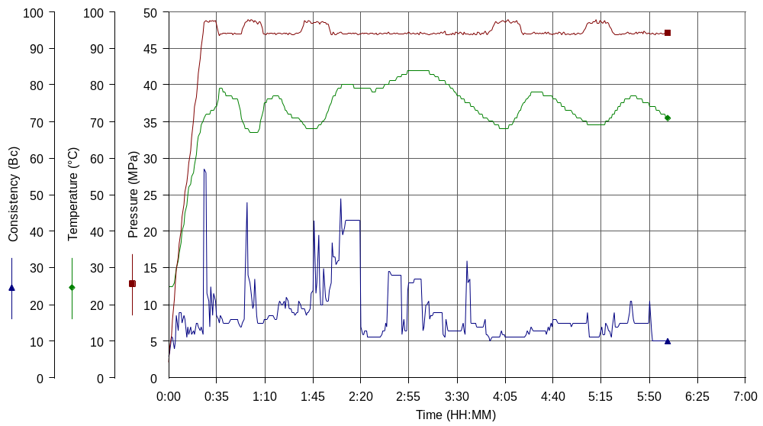

Test # 253
Instrument Name Consistometer
Instrument Type Consistometer
Test Start 04/04/01 11:19
Test Stop 2:51:20
Well ID # Uray 8639
Customer TPP"Uraineftegas"
Cement Class G
Additives 1.4%TDF-1+SodaAsh+Defoamer
Cement Mfr DYKERHOFF
BHCT 72
BHST 72
Density 1900
Fluid Loss
Job Type 146 MM CSG HESITATION SQUEEZE
Comments MPa: 46.9 (25min); T: 72C (25min); Premix; Kogalym TDF-1, Uray techn. water, Uray cement, standard API 15 min squeeze cycle.

